INTRODUCTION

Advent is a time to await with joyful expectation the coming of someone. But, how can one joyfully expect if he or she does not know anything of the one who is coming? He or she can never be excited at all nor expect at all. Instead, he or she can just be taken by what society is presenting about the coming Christmas season. We lose the true meaning of this time because of ignorance.

So much has been invested. But for what or for whom? That’s why the Church gives us the season of Advent, not only to prepare for our own personal conversion, but to get to know well the one who is coming.

This week, we are presented with passages of people coming and visiting. And we are invited to learn from the many attitudes shown in the passages especially from persons like Elizabeth, John the Baptist and Mother Mary, and how even in the midst of doubts and ignorance, they were able to recognize and welcome the one who has come in their lives.

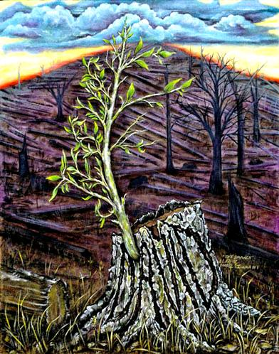

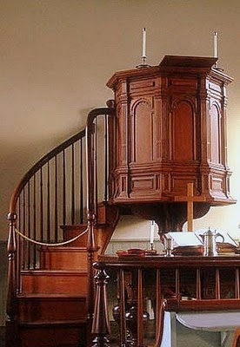**DYNAMISM OF THE WORD**





L

**MONDAY**

***Why should I be honoured with a visit from the mother of my Lord?***

***(Our Lady of Guadalupe)***

**Luke 1:39-45**  39 Mary set out at that time and went as quickly as she could into the hill country to a town in Judah. 40 She went into Zechariah's house and greeted Elizabeth. 41 Now it happened that as soon as Elizabeth heard Mary's greeting, the child leapt in her womb and Elizabeth was filled with the Holy Spirit. 42 She gave a loud cry and said, 'Of all women you are the most blessed, and blessed is the fruit of your womb. 43 Why should I be honoured with a visit from the mother of my Lord? 44 Look, the moment your greeting reached my ears, the child in my womb leapt for joy. 45 Yes, blessed is she who believed that the promise made her by the Lord would be fulfilled.'

*The passage of this day, celebrating the feast of Our Lady of Guadalupe, is the Visitation. We can learn from Elizabeth how she experienced being filled by the Holy Spirit recognizing who is the one coming to her. May we also experience the same with her, the feeling of being honoured and privileged to be visited by the Lord especially this coming Christmas season.*

**TUESDAY**

***There is no one except me.***

***(Memorial of St. Lucy)***

**Matthew 21:31-32**  Jesus said to them, 'In truth I tell you, tax collectors and prostitutes are making their way into the kingdom of God before you. 32 For John came to you, showing the way of uprightness, but you did not believe him, and yet the tax collectors and prostitutes did. Even after seeing that, you refused to think better of it and believe in him.

**Isaiah 45:6-8**  6 so that it may be known from east to west that there is no one except me. I am Yahweh, and there is no other, 7 I form the light and I create the darkness, I make well-being, and I create disaster, I, Yahweh, do all these things. 8 Rain down, you heavens, from above, and let the clouds pour down saving justice, let the earth open up and blossom with salvation, and let justice sprout with it; I, Yahweh, have created it!

*The Lord is coming and we are invited to believe that He is the only God and there is no other. This Advent is a time to learn to expect only Him coming this Christmas more than the other personalities in the world. Let us seek and joyfully expect for His presence as the greatest thing that will come.*

**WEDNESDAY**

***Are you the one who is to come?***

***(Memorial of St. John of the Cross)***

**Luke 7:18-23**  18 The disciples of John gave him all this news, and John, summoning two of his disciples, 19 sent them to the Lord to ask, 'Are you the one who is to come, or are we to expect someone else?' 20 When the men reached Jesus they said, 'John the Baptist has sent us to you to ask, "Are you the one who is to come or are we to expect someone else?" ' 21 At that very time he cured many people of diseases and afflictions and of evil spirits, and gave the gift of sight to many who were blind. 22 Then he gave the messengers their answer, 'Go back and tell John what you have seen and heard: the blind see again, the lame walk, those suffering from virulent skin-diseases are cleansed, and the deaf hear, the dead are raised to life, the good news is proclaimed to the poor; 23 and blessed is anyone who does not find me a cause of falling.'

*Doubts will come along the way that even John the Baptist experienced. Let us seek the truth in what we know of Jesus in the Scriptures. Let us enjoy deepening the truth in the Word of God this season.*

**THURSDAY**

***What did you go out to see?***

**Luke 7:24-30**  24 When John's messengers had gone he began to talk to the people about John, 25 'What did you go out into the desert to see? A reed swaying in the breeze? No! Then what did you go out to see? A man dressed in fine clothes? Look, those who go in magnificent clothes and live luxuriously are to be found at royal courts! 26 Then what did you go out to see? A prophet? Yes, I tell you, and much more than a prophet: 27 he is the one of whom scripture says: Look, I am going to send my messenger in front of you to prepare your way before you. 28 'I tell you, of all the children born to women, there is no one greater than John; yet the least in the kingdom of God is greater than he.' 29 All the people who heard him, and the tax collectors too, acknowledged God's saving justice by accepting baptism from John; 30 but by refusing baptism from him the Pharisees and the lawyers thwarted God's plan for them.

*What did you go out to see? With all the sacrifices, self-giving, preparations, money spent for this Christmas, what do you expect to see and happen? Who is the one you are expecting to come?*

**FRIDAY**

***A Son has been given to us.***

***(National Youth Day)***

**Isaiah 54:1-4**  Shout for joy, barren one who has borne no children! Break into cries and shouts of joy, you who were never in labour! For the children of the forsaken one are more in number than the children of the wedded wife, says Yahweh. 2 Widen the space of your tent, extend the curtains of your home, do not hold back! Lengthen your ropes, make your tent-pegs firm, 3 for you will burst out to right and to left, your race will dispossess the nations and repopulate deserted towns. 4 Do not fear, you will not be put to shame again, do not worry, you will not be disgraced again; for you will forget the shame of your youth and no longer remember the dishonour of your widowhood.

**Isaiah 9:5**  5 For a son has been born for us, a son has been given to us, and dominion has been laid on his shoulders; and this is the name he has been given, 'Wonder-Counsellor, Mighty-God, Eternal-Father, Prince-of-Peace'

*Let us widen the space of our hearts and of our minds for the one who is to come. Let us open gladly to Him, to fill our minds and our hearts of the knowledge and encounter of Him this season. “Who is this man?”*

**SATURDAY**

***Here is my servant.***

**Isaiah 42:1-4**  Here is my servant whom I uphold, my chosen one in whom my soul delights. I have sent my spirit upon him, he will bring fair judgement to the nations. 2 He does not cry out or raise his voice, his voice is not heard in the street; 3 he does not break the crushed reed or snuff the faltering wick. Faithfully he presents fair judgement; 4 he will not grow faint, he will not be crushed until he has established fair judgement on earth, and the coasts and islands are waiting for his instruction.

*Perhaps we have celebrated every year many Christmases but how wonderful if this year we can truly know Him deeply - for this is His celebration. That we can discover a new knowledge of Him this season.*

**SUNDAY**

**4th Sunday of Advent**

**1st Reading** – Isaiah 7:10-14

**Responsorial Psalm** – Psalm 24 **Reading –** Romans 1:1-7

**Gospel** – Matthew 1:18-24



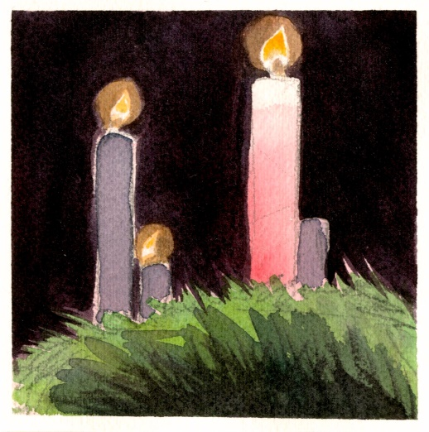



**GUIDELINES FOR PRAYER**



***The earth shall be filled with the knowledge of the Lord (Isaiah 11:9)***



December 12-18, 2016

**General Theme:** Eternity stepped into time.

**General Objectives:**

- to value the time given to us in the Church for the preparation and of change.

- to know more deeply who is the one coming.

- to celebrate with joy the mystery of Christmas.

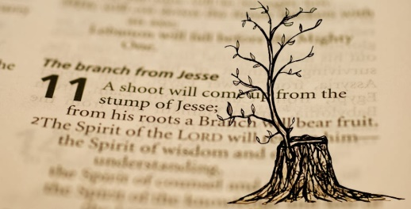

**Objective of the week:**

- to know the one who is coming.