**INTRODUCTION**

The Holy Spirit is the one leading Verbum Dei through history faithfully. He is the one moving people constantly in history to respond to the call of God. We need to realize and value so many lives that responded to the call and walked the journey of fidelity up to now in order that Verbum Dei can be who she is.

This week, we are invited to reflect on the current reality of the Verbum Dei family which is a fruit of its fidelity to the whispers of the Holy Spirit.

As Verbum Dei disciples, we are reminded of the VDMFa mission ---- “To live their dedication to prayer and ministry of the Word in the spirit of the First Christian Community and of the Twelve Apostles in their dedication to prayer and ministry of the Word, with the untiring missionary zeal of St. Paul, in his proclamation of the Word, formation of apostles, and creation of evangelizing communities.” Seek for the Holy Spirit’s guidance and enlightenment so as to carry out the VDMFa’s mission of love.



**PRAYING WITH THE WORD**

* “For ignorance of the Scriptures is ignorance of Christ.” ***St. Jerome***
* And let them remember that prayer should accompany the reading of Sacred Scripture, so that God and man may talk together; for “we speak to Him when we pray; we hear Him when we read the divine saying.” ***St. Ambrose***

***(Dei Verbum #25 Vatican II document)***

**DYNAMISM OF THE WORD**



L



**MONDAY**

***Follow Me***

***(Memorial of St. Lawrence)***

“24Very truly I tell you, unless a kernel of wheat falls to the ground and dies, it remains only a single seed. But if it dies, it produces many seeds.25Anyone who loves their life will lose it, while anyone who hates their life in this world will keep it for eternal life. 26Whoever serves me must follow me; and where I am, my servant also will be. My Father will honor the one who serves me.”

***(John 12:24-26)***

*Sometimes tragedies bring out the best in us. We learn more from misfortunes and sufferings than from our successes. Failure and death bear forth greater lessons and fruits in the end. It is said “God whispers in our triumphs but shouts in our trials. The cross brought out the best possible in man but brought out the best in God.” Today, recall the times of difficult changes in your life story and reflect on how the Holy Spirit has enlightened and guided you in the process.*

**TUESDAY**

***You gave your Good Spirit***

***(Memorial of St. Clare)***

**19**“Because of your great compassion you did not abandon them in the wilderness. By day the pillar of cloud did not fail to guide them on their path, nor the pillar of fire by night to shine on the way they were to take.**20**You gave your good Spirit to instruct them. You did not withhold your manna from their mouths, and you gave them water for their thirst. **21**For forty years you sustained them in the wilderness; they lacked nothing, their clothes did not wear out nor did their feet become swollen.” ***(Nehemiah 9:19-21)***

*Sacred history shows God’s love and mercy towards His people. The faithful enjoys the Lord’s provision, love, joy, peace, guidance and protection in their journey of life. Likewise the Verbum Dei family has experienced God’s goodness and provision. The Holy Spirit has been in the VD family’s journey of fidelity to HIS calling ---- to make apostles. What where the instances in your journey were you felt the Holy Spirit’s presence? Did you see the hand of God taking care of your bodily and spiritual needs?*

**WEDNESDAY**

***I have loved you with an everlasting love***

This is what the Lord says:

“The people who survive the sword will find favor in the desert; I will come to give rest to Israel.’ The Lord appeared to us in the past, saying: ‘I have loved you with an everlasting love; I have drawn you with loving – kindness.”

***(Jeremiah 31:2-3)***

*God knows our concern and troubles. But the Lord assures us that there is a way ---- Jesus. “All things work for good for those who love God.” (Romans 8:28). The Trinity, as Father who made everything, as Son who gave everything, and as Spirit who reminds us of this love-giving God ---- draws us to this everlasting love. What have you done in the name of love? What have you sacrificed for a loved one?*

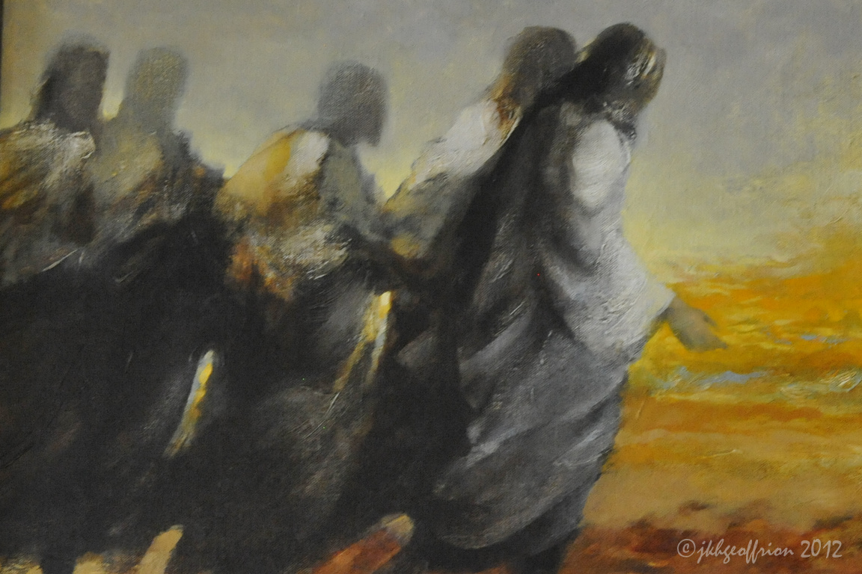

**THURSDAY**

***Stay With Me***

28 'You are the men who have stood by me faithfully in my trials; 29 and now I confer a kingdom on you, just as my Father conferred one on me: 30 you will eat and drink at my table in my kingdom, and you will sit on thrones to judge the twelve tribes of Israel. 31 'Simon, Simon! Look, Satan has got his wish to sift you all like wheat; 32 but I have prayed for you, Simon, that your faith may not fail, and once you have recovered, you in your turn must strengthen your brothers.'

***(Luke 22:28-32)***

*We are never totally alone. To the faithful, we feel how Jesus felt in the last supper on how HIS disciples have stayed in all through His trials. We are all tied together (with the Trinity) and whatever we do has an impact/effect on others. To be connected with Jesus is to be connected in prayer. And to connect with others is to be conscious of them --- to care and love them. Pray and do an act of service for another person today.*

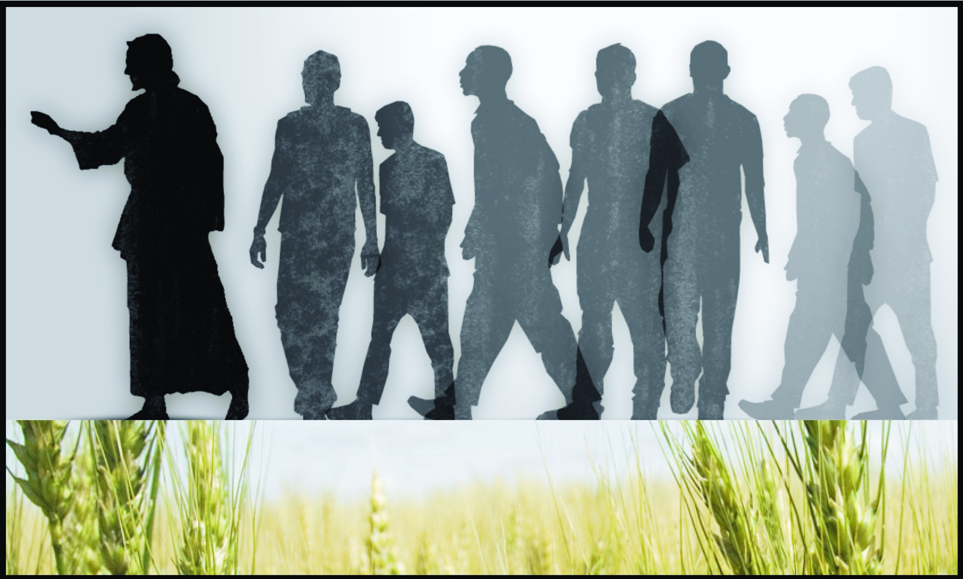

**FRIDAY**

***God began a good work in you***

***(Memorial of St. Maximilian Kolbe)***

2 Grace and peace to you from God our Father and the Lord Jesus Christ. 3 I thank my God whenever I think of you, 4 and every time I pray for you all, I always pray with joy 5 for your partnership in the gospel from the very first day up to the present. 6 I am quite confident that the One who began a good work in you will go on completing it until the Day of Jesus Christ comes. 7 It is only right that I should feel like this towards you all, because you have a place in my heart, since you have all shared together in the grace that has been mine, both my chains and my work defending and establishing the gospel.

***(Philippians 1:2-7)***

*Believers know that faith does not solve everything. God calls us to find new paths through the daily concerns of life. To grow in the path of holiness, we need to reflect and be attentive to the whispers and calling of the Holy Spirit. Persevere in the journey in order to finish the race. Likewise encourage, pray and help others finish the race.*

**SATURDAY**

***The Magnificat***

***(Assumption of the Blessed Virgin Mary)***

46 And Mary said: My soul proclaims the greatness of the Lord 47 and my spirit rejoices in God my Saviour; 48 because he has looked upon the humiliation of his servant. Yes, from now onwards all generations will call me blessed, 49 for the Almighty has done great things for me. Holy is his name, 50 and his faithful love extends age after age to those who fear him. 51 He has used the power of his arm, he has routed the arrogant of heart. 52 He has pulled down princes from their thrones and raised high the lowly. 53 He has filled the starving with good things, sent the rich away empty. 54 He has come to the help of Israel his servant, mindful of his faithful love 55 -according to the promise he made to our ancestors -- of his mercy to Abraham and to his descendants forever.

***(Luke 1:46-55)***

*Mary is a model of self-giving as such that she put all she had at God’s disposal. In an instant, all her personal plans were done with, so that she could do everything God wanted of her. We praise God for raising up the humble Virgin of Nazareth as our Model and Mother. Today is the assumption of Mary ---- which is also about us. We are called to live totally for God, persevere in our following Jesus and tell others about HIM.*

**SUNDAY READINGS**

**20th Sunday in Ordinary Time**

**1st Reading:** Proverbs 9:1-6

**Responsorial Psalm:** Psalm 34

**2nd Reading:** Ephesians 5:15-20

**Gospel:** John 6:51-58

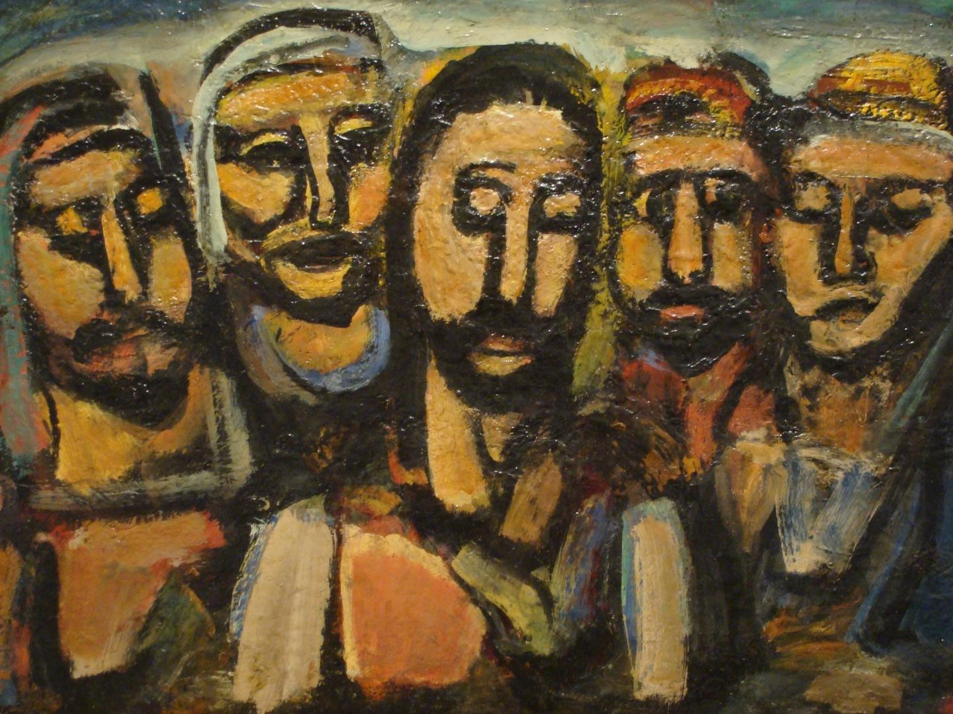

**GUIDELINES FOR PRAYER**



***“You have stayed with me all through my trials.” (Luke 22:28)***



August 10-16, 2015

**General Theme:** “The Process of Incarnation of the Verbum Dei charism.”

**General Objective:**

To read our current history of the Philippines in the light of the way the Church and the Verbum Dei worldwide are doing.

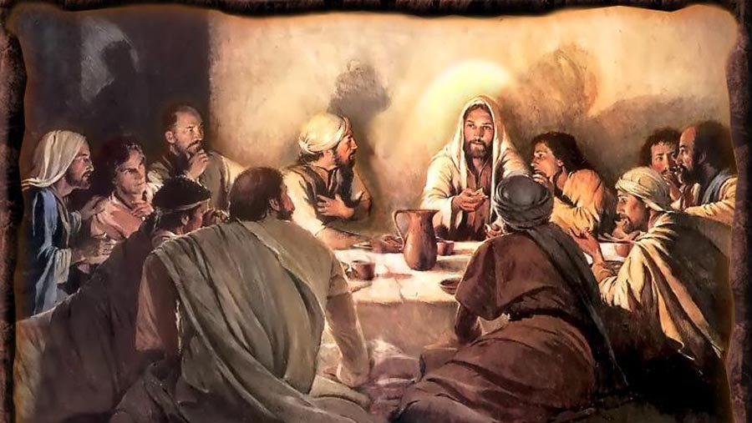

**Objective of the week:**

To be aware that the current reality of Verbum Dei is a fruit of a long journey of fidelity to the calling of the Holy Spirit.