**INTRODUCTION**

In preparation for the upcoming weeklong Annual Disciples’ Retreat this month, we will deepen on the topics proposed for it. To respond to the primary apostolic intention of the Verbum Dei Missionary Family this year, which was the Missionary Expansion, we will follow as closely as possible the footsteps of Jesus in His public ministry. Every week we will focus on certain moments of Jesus’ mission with His disciples.

Jesus was forming his disciples. And as they follow Him, they understood that the basis of their mission depends on their relationship with Him.

This week, we will look at two important events in the public ministry of Jesus. The miracle at Cana and the Cleansing of the Temple. We start by praying with Mama Mary during the very first moments of Jesus’ public ministry – His first miracle. By that miracle, He confirmed and strengthened the faith of the disciples. We also look at Mary’s response to Jesus telling the servants, “Do whatever he tells you.” (John 2:5) It shows us Mary’s total trust in the Word of God. Mary is a model Disciple for us as she says, “Do whatever he tells you.” We can have her as our best model for discipleship because of her yes. We find in her the zeal to do whatever Jesus says. This same zeal can be seen in Jesus as well as he went to cleanse the Temple; the zeal to do the Father’s will; the zeal for God’s temple in the lives of others.

As we journey with Jesus and Mama Mary this week, may our being witnesses to His love and self-giving, make of our discipleship models for others to follow.

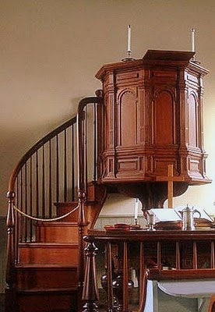**DYNAMISM OF THE WORD**





L

**MONDAY**

***The miracle of transformation***

**John 2:1-11**  On the third day there was a wedding at Cana in Galilee. The mother of Jesus was there, 2 and Jesus and his disciples had also been invited. 3 And they ran out of wine, since the wine provided for the feast had all been used, and the mother of Jesus said to him, 'They have no wine.' 4 Jesus said, 'Woman, what do you want from me? My hour has not come yet.' 5 His mother said to the servants, 'Do whatever he tells you.' 6 There were six stone water jars standing there, meant for the ablutions that are customary among the Jews: each could hold twenty or thirty gallons. 7 Jesus said to the servants, 'Fill the jars with water,' and they filled them to the brim. 8 Then he said to them, 'Draw some out now and take it to the president of the feast.' 9 They did this; the president tasted the water, and it had turned into wine. Having no idea where it came from -- though the servants who had drawn the water knew -- the president of the feast called the bridegroom 10 and said, 'Everyone serves good wine first and the worse wine when the guests are well wined; but you have kept the best wine till now.' 11 This was the first of Jesus' signs: it was at Cana in Galilee. He revealed his glory, and his disciples believed in him.

*What concrete “sign” (miracle) led you to put more your trust in Jesus? What is the “wine-level” (joy to follow Christ) in your life of discipleship? Running out fast? Half-full? Empty? Only water? Has Mary a special place in your following of Jesus?*

*Is my life a witness of Jesus’ miracle from water to wine?*

**TUESDAY**

***Models for others to imitate***

***(Solemnity of All Saints)***

**2 Thessalonians 3:7-9**  7 You know how you should take us as your model: we were not undisciplined when we were with you, 8 nor did we ever accept food from anyone without paying for it; no, we worked with unsparing energy, night and day, so as not to be a burden on any of you. 9 This was not because we had no right to be, but in order to make ourselves a model for you to imitate.

*Discipleship is not just a personal gain or benefit. When we follow Jesus, and become his disciples, our lives are transformed to something worth imitating. Like the saints, on which we celebrate today, became models of discipleship worthy of imitation. Is my life worthy of imitating?*

**WEDNESDAY**

***Be united in imitating me***

***(Commemoration of All the Faithful Departed)***

**Philippians 3:16-21**  16 Meanwhile, let us go forward from the point we have each attained. 17 Brothers, be united in imitating me. Keep your eyes fixed on those who act according to the example you have from me. 18 For there are so many people of whom I have often warned you, and now I warn you again with tears in my eyes, who behave like the enemies of Christ's cross. 19 They are destined to be lost; their god is the stomach; they glory in what they should think shameful, since their minds are set on earthly things. 20 But our homeland is in heaven and it is from there that we are expecting a Saviour, the Lord Jesus Christ, 21 who will transfigure the wretched body of ours into the mould of his glorious body, through the working of the power which he has, even to bring all things under his mastery.

*St. Paul was aware that his perseverance and his discipleship are stepping stones and encouragement for others who are running the same race. In the midst of His failures, he is not ashamed to run and encourage others to follow his same example. Let us not be ashamed of our process of discipleship but continue to be examples for others.*

**THURSDAY**

***I am eaten up with zeal for your temple***

***(St. Martin de Porres)***

**John 2:13-22**  13 When the time of the Jewish Passover was near Jesus went up to Jerusalem, 14 and in the Temple he found people selling cattle and sheep and doves, and the money changers sitting there. 15 Making a whip out of cord, he drove them all out of the Temple, sheep and cattle as well, scattered the money changers' coins, knocked their tables over 16 and said to the dove sellers, 'Take all this out of here and stop using my Father's house as a market.' 17 Then his disciples remembered the words of scripture: I am eaten up with zeal for your house. 18 The Jews intervened and said, 'What sign can you show us that you should act like this?' 19 Jesus answered, 'Destroy this Temple, and in three days I will raise it up.' 20 The Jews replied, 'It has taken forty-six years to build this Temple: are you going to raise it up again in three days?' 21 But he was speaking of the Temple that was his body, 22 and when Jesus rose from the dead, his disciples remembered that he had said this, and they believed the scripture and what he had said.

*What issues do I have in my discipleship that prevents me to move forward? What makes my life a marketplace?*

*How is your zeal for the temple of God in the hearts of the people?*

*Is it obvious in my missionary commitment the zeal for God’s temple in the lives of others?*

**FRIDAY**

***The opportunity to bear witness***

***(St. Charles Borromeo)***

**Luke 21:12-15**  you will be seized and persecuted; you will be handed over to the synagogues and to imprisonment, and brought before kings and governors for the sake of my name 13 -and that will be your opportunity to bear witness. 14 Make up your minds not to prepare your defence, 15 because I myself shall give you an eloquence and a wisdom that none of your opponents will be able to resist or contradict.

*It is expected that to be a disciple, there will be challenges and persecutions because we are in the world. But instead of running away from them, as disciples, we see them as opportunities to bear witness to the Gospel. How do I see the concrete challenges of discipleship in my life?*

**SATURDAY**

***The water that flows from the temple gives life***

**Ezekiel 47:6-12**  6 He then said, 'Do you see, son of man?' He then took me and brought me back to the bank on the river. 7 Now, when I reached it, I saw an enormous number of trees on each bank of the river. 8 He said, 'This water flows east down to the Arabah and to the sea; and flowing into the sea it makes its waters wholesome. 9 Wherever the river flows, all living creatures teeming in it will live. Fish will be very plentiful, for wherever the water goes it brings health, and life teems wherever the river flows. 10 There will be fishermen on its banks. Fishing nets will be spread from En-Gedi to En-Eglaim. The species of fish will be the same as the fish of the Great Sea. 11 The marshes and lagoons, however, will not become wholesome, but will remain salt. 12 Along the river, on either bank, will grow every kind of fruit tree with leaves that never wither and fruit that never fails; they will bear new fruit every month, because this water comes from the sanctuary. And their fruit will be good to eat and the leaves medicinal.'

*As models and witnesses of the love and mercy of God, we must be aware that we are life-givers. May our union with Christ flow freely through our lives like water that nourishes and gives life to those who imitate us and see us as models for discipleship.*

**SUNDAY**

**32nd Sunday in Ordinary Time**

**1st Reading:** 2 Maccabees 7:1-2, 9-14

**Responsorial:** Psalm 17

**2nd Reading:** 2 Thessalonians 2:16-3:5

**Gospel:** Luke 20:27-38

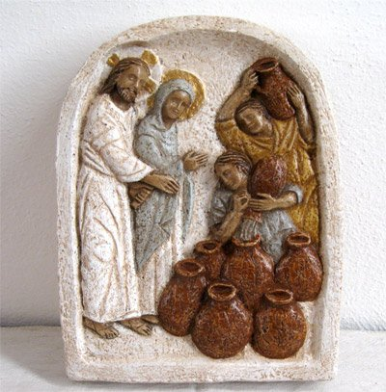

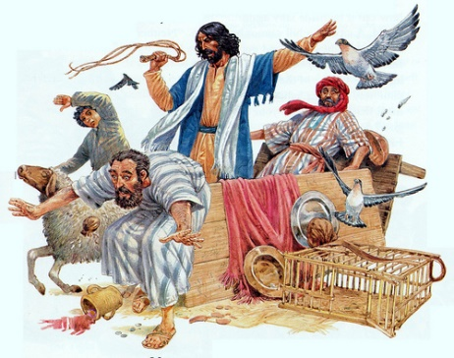



**GUIDELINES FOR PRAYER**



***Disciples – Models of discipleship***



October 31- November 6, 2016

**General Theme:**  Disciples – being true witnesses of Jesus’ love and self-giving.

**General Objectives:**

- to strengthen the relationship of us disciples with the person of Christ whose urgency of giving life and love is the basis of our missionary expansion.

- to follow the footsteps of Jesus as closely as possible in his public ministry.

- to allow Him to illumine our journey of missionary expansion and inspire us with His same sentiments towards others.

**Objective of the week:**

- that our life be Jesus’ miracle of transformation

- to increase our zeal for God’s temple in the lives of others.